Part III Verniers and the Caliper

http://www.rit.edu/~uphysics/VernierCaliper/caliper.html

A manual on

Uncertainties, Graphing, and the Vernier Caliper

Vern Lindberg, Copyright August 15, 2003

A manual on Uncertainties, Graphing and the Vernier Caliper

Part 1-Uncertainties and Error Propagation (不準確度和誤差傳遞)

Part 2-GRAPHING (作圖)

Part 3-The Vernier Caliper (游標尺)

Part III Verniers and the Caliper

Table of contents and glossary
1. Vernier scales
2. The Vernier Caliper
3. Digital Electronic Calipers
Term | Brief definition
Caliper | A tool that can be used to measure outside dimensions, inside dimensions, or depths of holes.
Instrument least count | The size of the smallest division on a scale. For the main scale on the common vernier caliper this is probably 0.1 cm. With the vernier scale the least count might be 0.002 cm.
Main Scale | The scale on the larger, fixed portion of the caliper. It gives the most significant digits in the reading. Make the reading to the nearest least count of the main scale opposite the zero of the vernier.
Vernier scale | The scale on the smaller sliding portion of the caliper. It gives the least significant digits in the reading, and sub-divides a mark on the main scale into 10, 20, or 50 subdivisions. Read the vernier scale at the point where a vernier line and a main scale line best line up. Combine the main scale reading with the vernier scale reading to get a final reading.

1. Vernier scales
Most common measuring instruments have a simple scale. For example in using a ruler, the ruler is placed next to the item being measured and the mark closest to the end of the item is recorded. If we want increased precision, we use a ruler with finer divisions on the scale, that is a smaller instrument least count. This is suggested in Figure 1.
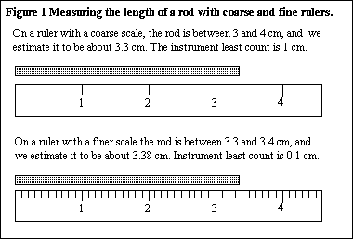
The ability to use high precision scales is limited by the spacing between the marks. Thus it is easy to have a least count of 1 mm, more difficult to have a least count of 0.2 mm, and virtually impossible to have a least count of 0.002 mm (a human hair has a diameter of about 0.050 mm.) In order to increase precision we need an auxiliary scale called a vernier scale. The vernier scale subdivides the least count from the main scale into 10, 50 or 100 subdivisions. Vernier scales are found on a wide range of instruments. In Section 2 we will discuss the vernier caliper.
Any instrument that uses a vernier will have two scales, a main scale and a vernier scale as is seen in Figure 2. A measurement is made by combining the readings from the two scales.
The main scale works just like a ruler: the 0-mark on the vernier is compared to a main scale and the result is written down. Use the mark next to the zero, not the mark next to the edge of the vernier. Be sure to record the value of the main scale mark that is just to the left of the vernier zero mark as is shown in the above diagram. That is, record the value of 3.3 cm rather than 3.4 cm, even though the answer is closer to 3.4 cm.
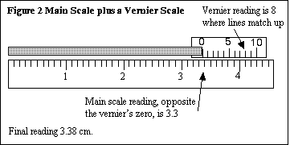
Now look closely at the vernier scale in Figure 2. Notice that 10 divisions on the vernier match 9 divisions on the main scale. This guarantees that one of the vernier markings will line up exactly with a mark on the main scale. Decide which vernier mark comes closest to matching a main scale mark, in our example this is vernier mark 8. Combine the two readings to give the final length of 3.38 cm.
Common mistakes:
- Do not try to read the main scale at the point where the lines match best. This has no meaning. Read from the vernier scale instead.
- Sometimes it is difficult to tell whether the best match of lines is for vernier marks 9, 0, or 1. Make your best estimate, but realize that the final result including the vernier must round off to the result you would choose if there was no vernier. If the mark is close to 3.20 on the main scale, but the vernier reading is 9, the length is 3.19 cm. If the mark is close to 3.2 on the main scale and the vernier is 1, the length is 3.21 cm.
A good way to learn about reading verniers is to use Fu-Kwun Hwang's Java Applet . When you go to this site, click in the check box next to "show". Then drag the movable scale with the mouse. A red arrows will show the reading on the main scale and the reading on the vernier, and the final reading is shown on the arrow separatitng the jaws of the caliper. Once you get the hang of reading the vernier caliper, try unchecking the "show" box, moving the jaw, making a reading, and checking your reading by checking the "show" box.

2. The Vernier Caliper
Figure 3 shows a common use for a vernier called a vernier caliper. This caliper can measure the outside diameter of an object (outside vernier), the inside diameter of a hole (inside caliper), or the depth of a hole (depth probe). The figure includes directions on the use of the vernier caliper.
We will most often measure outside diameters. One jaw of the caliper is fixed, and the other jaw moves and is connected to the vernier.
- Check that the vernier caliper correctly reads zero when the jaws are closed. (if not, check with the lab instructor.)
- Close the jaws around the object but do not over tighten. The jaws should exert a firm pressure on the object.
- When both locking screws are tightened the caliper can be removed from the object and read without worrying if the jaws will shift position.
  - You can read the main scale to the nearest tenth of a centimeter.
  - The vernier consists of 50 divisions, meaning that 0.1 cm is divided into 50 parts and the final least count is 0.1 cm/50 = 0.002 cm = 1/50 mm. Read the vernier as described in the previous section, with a result like 1.4 or 1.6 or 2.0. A reading of 1.6 from the vernier really means 0.016 cm which is added to the main scale reading to give the final diameter of 3.216 cm.
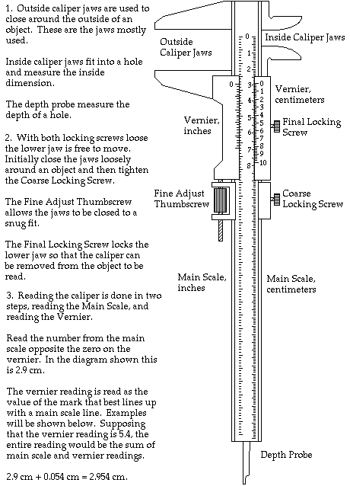

Figure 3. A complete vernier caliper

3. Digital Electronic Calipers
You may be using electronic calipers. These have an electronic readout rather than a vernier scale. Typically an electronic caliper will have three buttons, an on/off button, an English/Metric button, and a Zero button. The procedure of using an electronic caliper is:
- Turn the caliper on.
- Select English (inches) or Metric (millimeters) reading--almost always in physics you would choose metric.
- Close the caliper jaws and press the Zero button.
- Measure the desired object and read the digital readout.

